SIMATS ENGINEERING (SAVEETHA SCHOOL OF ENGINEERING)
Department of Computer Science and Engineering

ASSESSMENT TOOL 1 – PSEUDOCODE WRITING

Course Code: | ITA03 | Course Title: | Mobile computing
CO Assessed: | CO3 – Precision (BL3) | Assessment: | Assessment Tool 1– Pseudocode
Weightage: | 30 % of CIA | Total Marks: | 100
CO3 Statement: | Implement wireless networking and Mobile IP concepts for routing in cellular and ad hoc networks..  (BTL 3)
Student Name: | K Muni Kuladeep | Reg. No.: | 192311096
Section / Batch: | CSE | Date: | 10/27/2026

Code of Conduct
I K. Muni Kuladeep/192311096 (Name / Reg No) certify that this submission is my original work and that I have adhered to the guidelines specified for this assessment. I understand that any violation of academic integrity rules will result in disciplinary action.
Signature of the Student: K Muni Kuladeep

Instructions
- Duration: 1 hour
- Answer all Questions
- Write Pseudocode in paper and upload program in GITHUB

Faculty In-charge | Course Coordinator | Head of Department
Signature: _______________ | Signature: _______________ | Signature: _______________
Date: ___________________ | Date: ___________________ | Date: ___________________

Questions

- Design a health and self-care mobile app that helps users maintain mental wellbeing with meditations and exercises. This case study talks you through the design process of creating a user- friendly mobile app. Design UI with the following requirements.
• User Login
  - Register
  - Health Routine Blogs
  - Self-Care Blogs
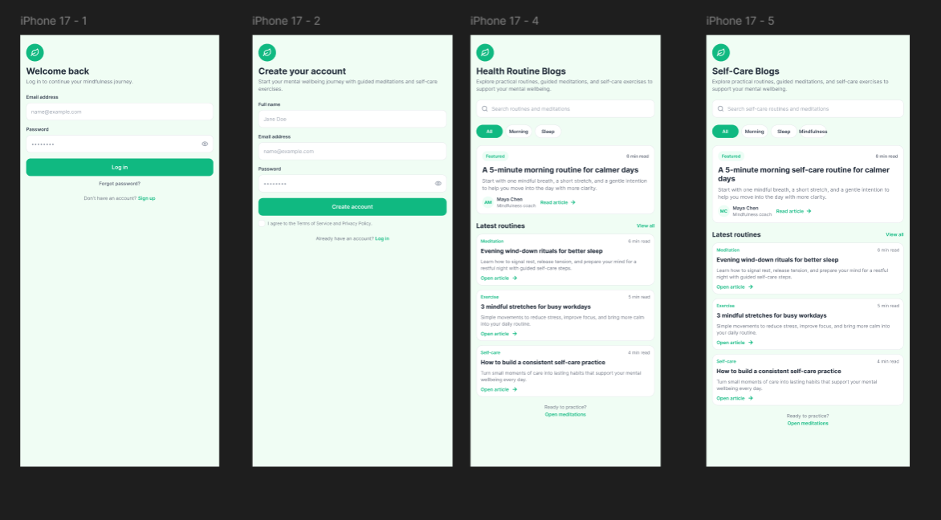

- This is an intelligent job assistant that helps users find their ideal job and get to all the way to signing a contract faster and more easily. Design UI with the following requirements.
  - User Login
  - Register Subscription
  - Personal Detail
  - Resume Upload
  - Choosing Job

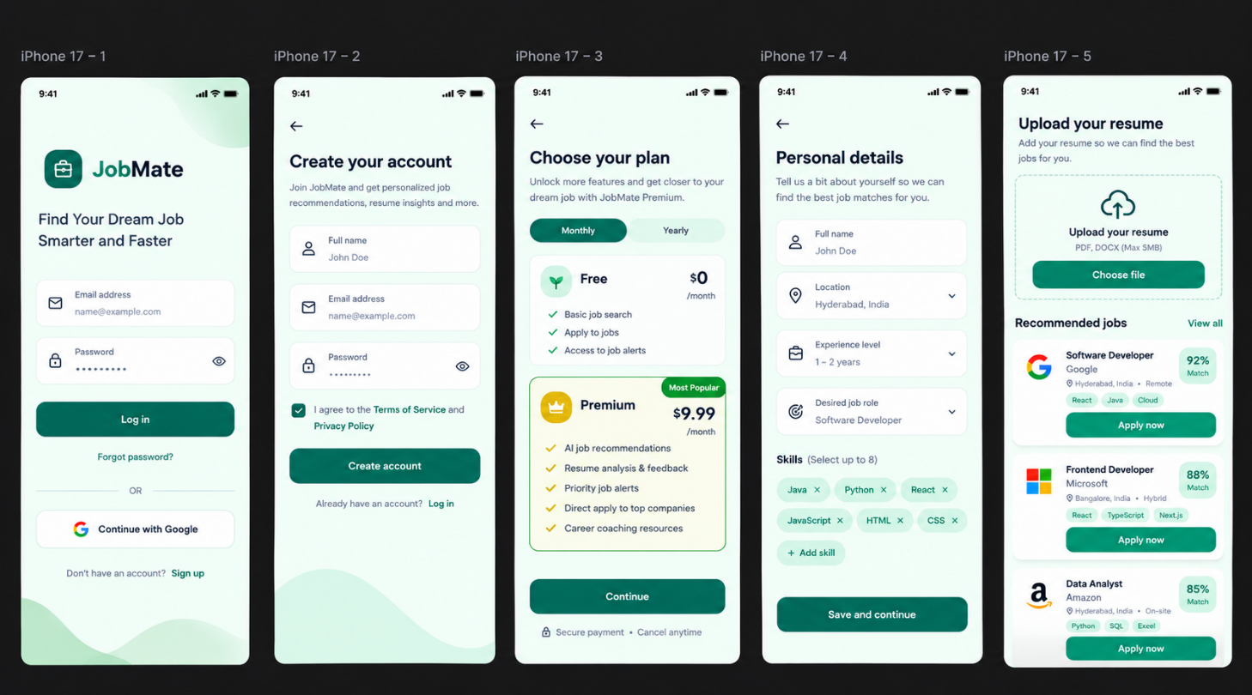

- This is a mobile app that can help people get parking slots easily even when they travel beyond their normal routes. Design UI with the following requirements.
  - UserLogin
  - Register Count of Empty Parking
  - Free Parking Slots Display
  - Booking Parking Slots

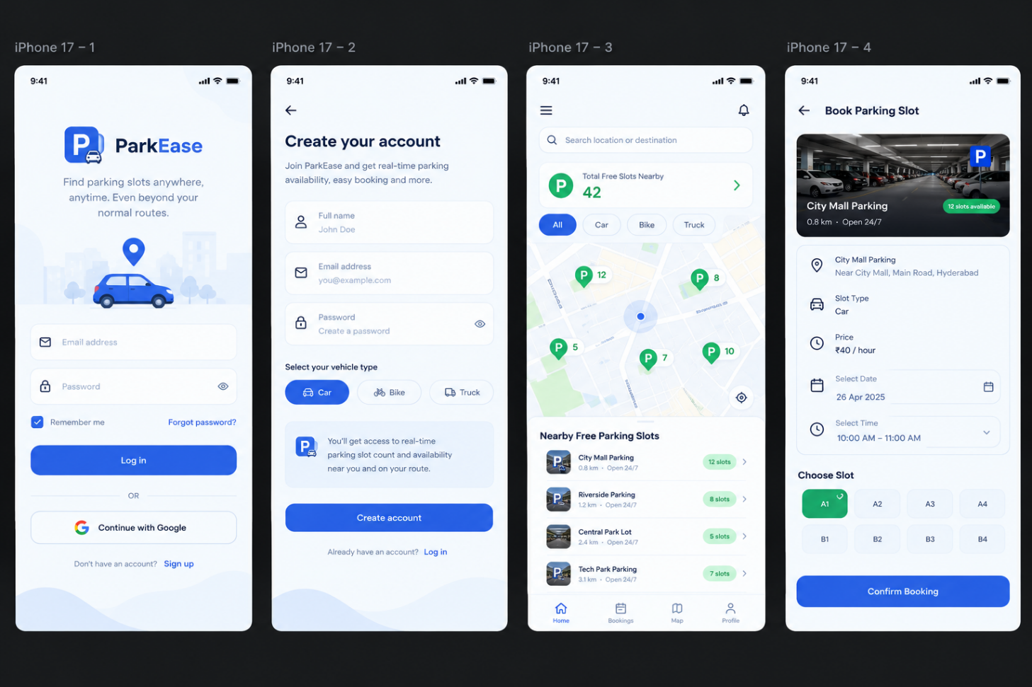

- Design a mobile app for Online Body Fitness tips and videos for a good daily routine. Contains the following requirements.
User Login
    - Register
    - Fitness Blog
    - Diet Planner
    - Fitness Videos
    - Payment and Subscription
